GENERAL School Supply Lists for your 2021-2022
McGregor Cougars!
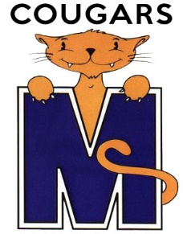
TK
● Box of crayons
● Pack of markers
● Scissors
● Bottle of Elmer’s glue
● 2 rolls of masking tape
● ½ inch binder (any color)
● 5 pounds of rice (for your child’s usage only)
● 5 pounds of beans (for your child’s usage only)
● Pencil box to store your child’s supplies
● Box of gallon storage bags
● 2 Boxes of tissues
● Backpack
● Lunch box
● 2 Personal snack bags (AM/PM) for your child

